**DAILY ONLINE ACTIVITIES SUMMARY**

|  |  |  |  |  |  |  |  |  |
| --- | --- | --- | --- | --- | --- | --- | --- | --- |
| **Date:** | **19-05-2020** | | | | | **Name:** | **Nachiketh S Bhat** | |
| **Sem & Sec** | **6th - B** | | | | | **USN:** | **4AL17CS119** | |
| **Online Test Summary** | | | | | | | | |
| **Subject** | | **CGV** | | | | | | |
| **Max. Marks** | | **60** | | **Score** | | | **57** | |
| **Certification Course Summary** | | | | | | | | |
| **Course** | **Machine learning with python** | | | | | | | |
| **Certificate Provider** | | | **Cognitiviclass.ai (IBM)** | | **Duration** | | | **4of 10** |
| **Coding Challenges** | | | | | | | | |
| **Problem Statement: One C-program two-java and one-python** | | | | | | | | |
| **Status: All executed** | | | | | | | | |
| **Uploaded the report in Github** | | | | | **yes** | | | |
| **If yes Repository name** | | | | | <https://github.com/nachi0106/Daily-Activity/tree/master/Online-coding%20report/19-05-20> | | | |
| **Uploaded the report in slack** | | | | | **Yes** | | | |

Online Test Details:

First I A of CGV

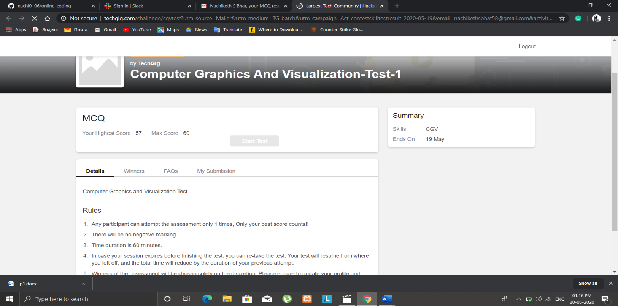

Certification Course Details:

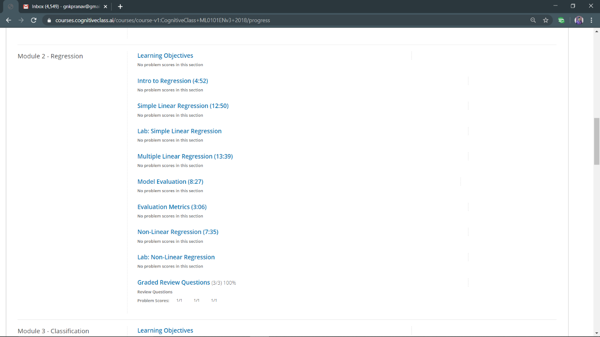

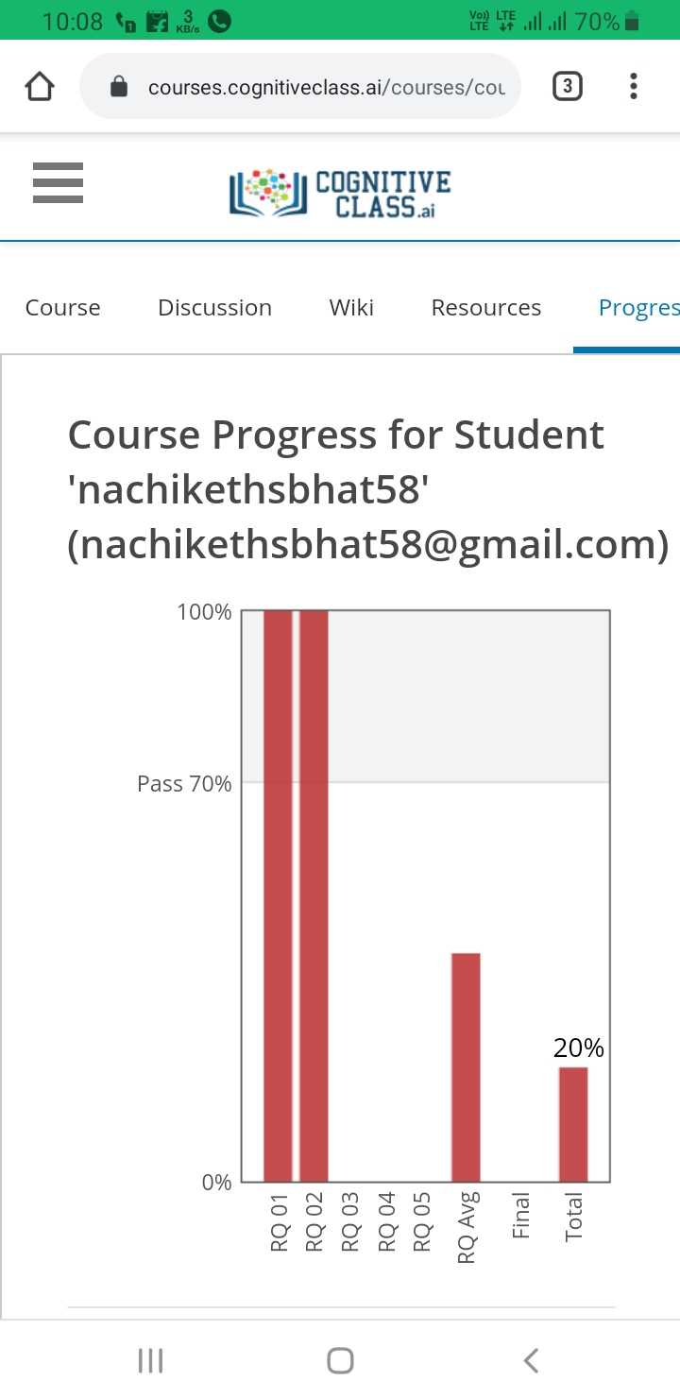

Coding Challenges Details:

Output screen shots

1

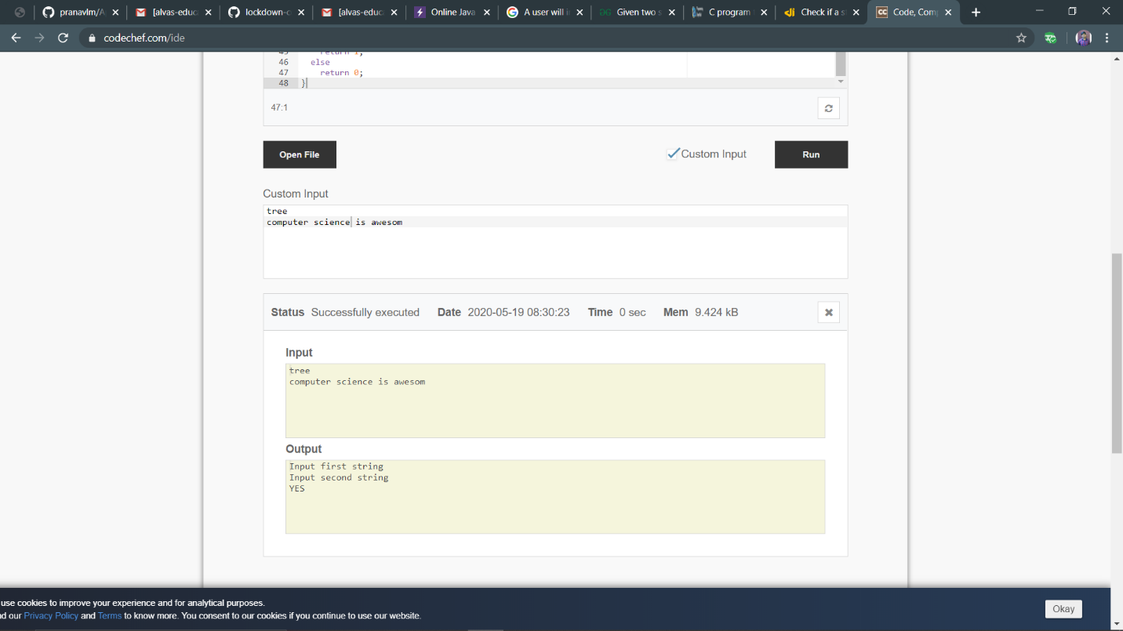

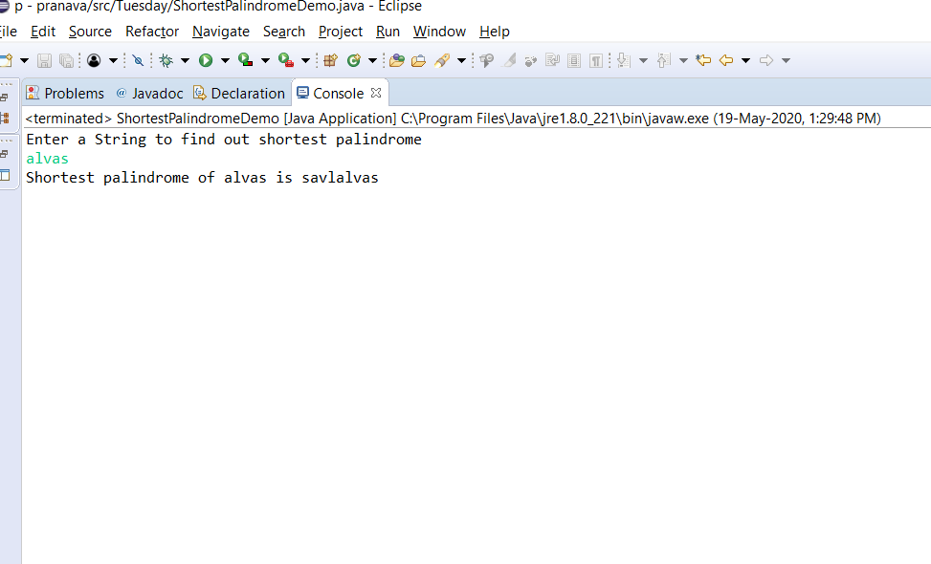 2

3

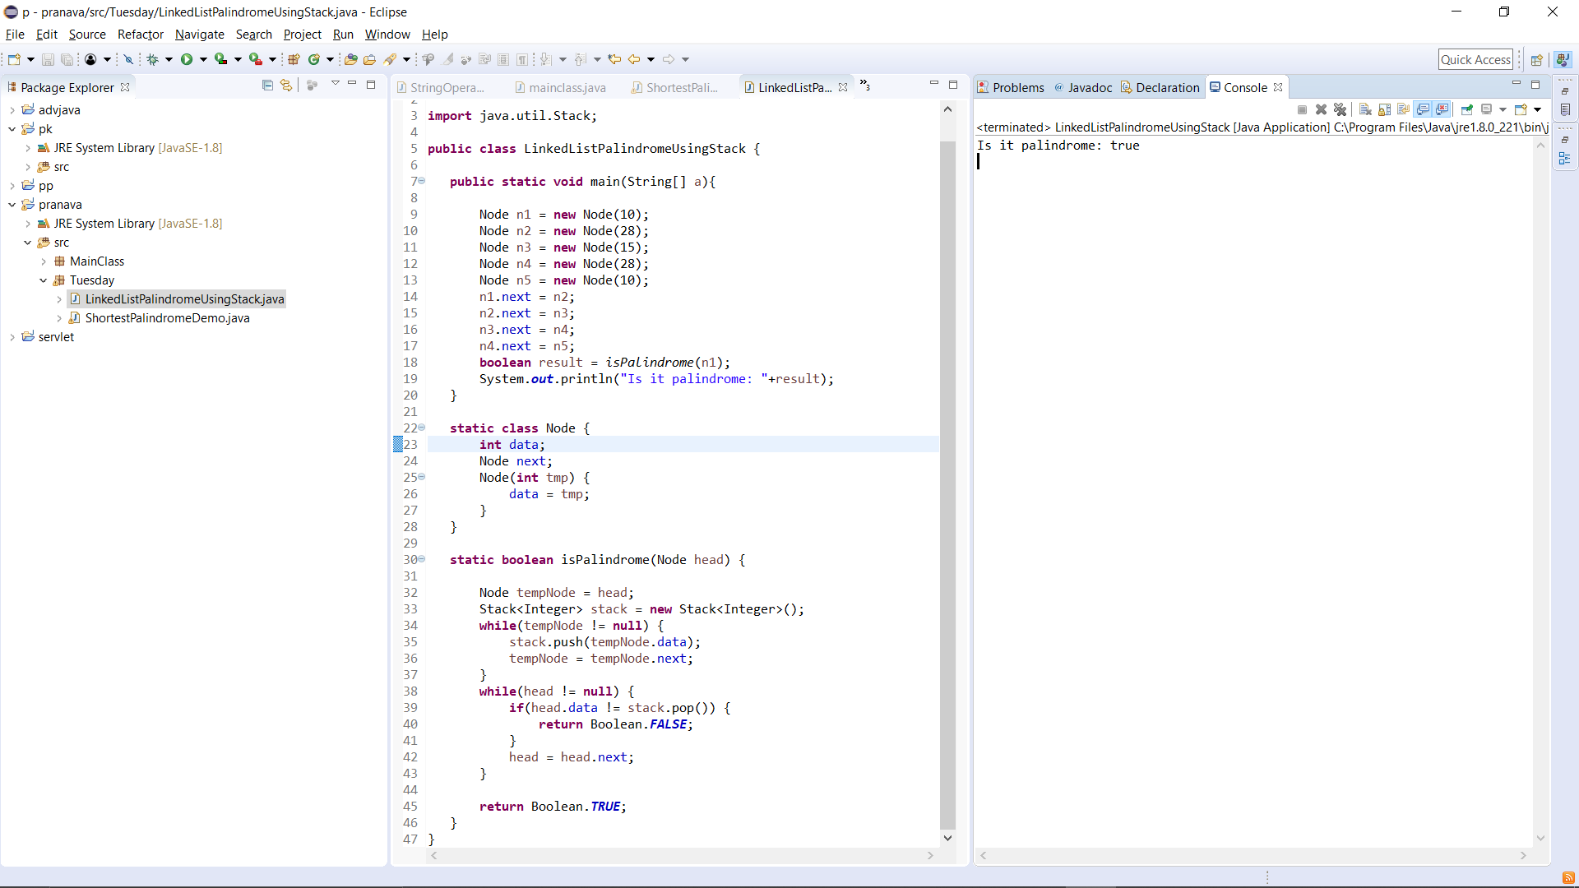

P-3B

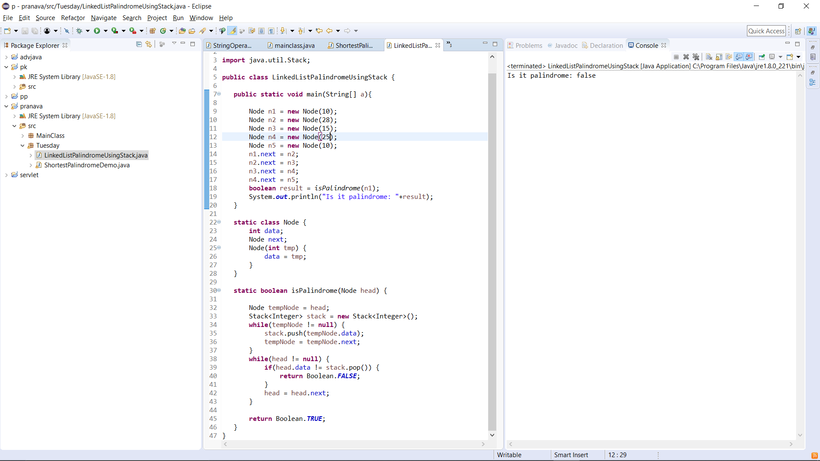

4

